2022 Annual Winter CME Conference
February 19, 2022

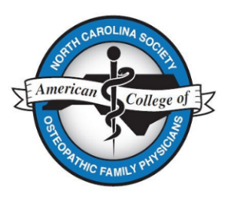
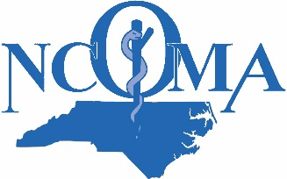
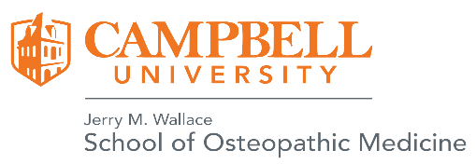

Registration Form
Name ______________________________________________________________________
Email __________________________________
Select the Registration Fee Amount Below
Rates: Payment Made by 1/31/22 After 1/31/22
NCOMA or NCS-ACOFP dues-paying member $125.00 $175.00
Non- Member Physician $225.00 $275.00
Active Duty Military Physician (not a member) $175.00 $200.00
Health Care Professional (Nurse, PA, NP) $125.00 $150.00
Student $35.00 $45.00
Resident $50.00 $75.00
Total Amount Due for Conference $
Dietary Issues
The registration fee includes breakfast, lunch and snacks. Do you have any dietary allergies?
☐ Yes (If yes, please describe.)
☐ No

Select Payment Type
☐ Pay by check (Make payable to Campbell University and mail to Brianne Homes, PO Box 4280, Buies Creek, NC 27506.)
☐ Pay by credit card (Register and pay on-line using this link.)
Hotel Information
Microtel Inn and Suites by Wyndham Lillington (To receive any available discounts, indicate that you are attending a conference at Campbell University. Call 1-910-893-2626 to make your reservation.)
Hampton Inn and Suites in Dunn. To inquire about discounts for events associated with Campbell University, call 1-910-892-4333.

