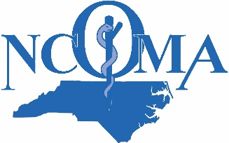
NCOMA CME Conference
March 2, 2019
The Great Wolf Lodge, Concord NC

Registration Form
Name ________________________ Type CME Credit Requested (AMA or AOA): __________
Phone _______________________________ Email __________________________________
Registration Fees
Rates: Payment Made by 2/15/19 On or After 2/16/19
NCOMA or NCS-ACOFP dues-paying member $275.00 $325.00
Non- Member Physician $375.00 $425.00
Active Duty Military Physician (not a member) $300.00 $350.00
Health Care Professional (Nurse, PA, NP) $250.00 $300.00
Student* $40.00 $50.00
Resident $75.00 $85.00
Guest* (Enter # ___) $35.00 $35.00
*Guest rate is for individual eating lunch meal only.
Join us for the Charlotte Hornets Game on Sunday, March 3, 2019 at 1:00 pm. Group tickets cost $30.00. Indicate here how many tickets, you wish to purchase: ___________
Total Amount Due for Conference and Game $_____________
Payment Methods
____ Pay by check (Make payable to NCOMA and mail to Nancy Guy, PO Box 4280, Buies Creek, NC 27506.)
____ Pay by credit card (Register and pay on-line at here.) On-line link will be added here.
Hotel Information
The Great Wolf Lodge is offering a conference room rate of $209.99 plus tax. The resort fee is waived for conference attendees. This rate applies for Friday and Saturday nights and includes Family Suites and the Luxury Suites (both room types sleep up to six people and include access to Water Park). Reserve room by February 2 to receive special rate. Call Central Reservations at 1-866-751-9653 and use Reservation Room Block Code 1903NCOM.
Conference Hours
The conference will begin at 8:00 am on Saturday, March 2 and end at 4:00 pm.
For Additional Information: Contact Nancy Guy, Director at 910-893-7960 or by e-mail at guy@campbell.edu.

